

European Senior Teams Championship 2011
2 - 12 May 2011, Olympus, Greece
Thessaloniki-Halkidiki Perfecture

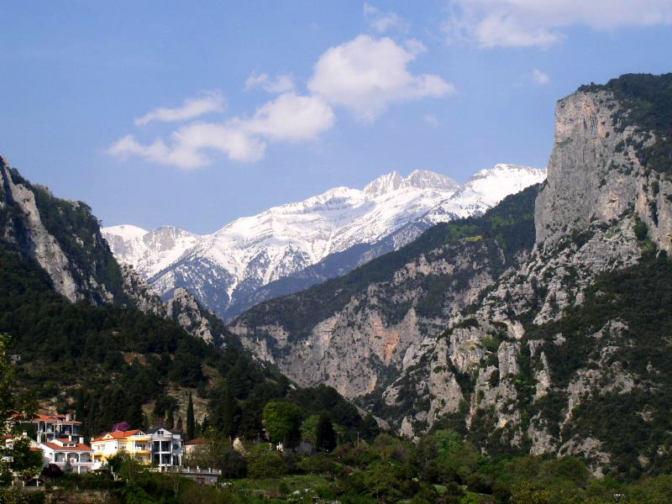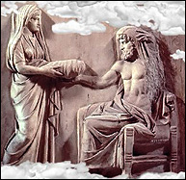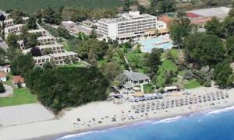

Traditionally regarded as the heavenly abode of the Greek gods and the site of the throne of Zeus, Olympos seems to have originally existed as an idealized mountain that only later came to be associated with a specific peak. The early epics, the Illiad and the Odyssey (composed by Homer around 700BC) offer little information regarding the geographic location of the heavenly mountain and there are several peaks in Greece. The most favored mythological choice is the tallest mountain range in Greece, the Olympos massif, 100 kilometers southwest of the city of Thessaloniki in northern Greece. The Venue Olympian Bay is a beachfront resort Hotel located in one of the greatest historical regions in Greece, at the foot of mountain Olympus near by ancient town of Dion with the famous ancient theatre, and 90 km from Thessaloniki airport.

TOURNAMENT REGULATIONS

- ORGANIZERS, VENUE

The European Chess Union, Greek Chess Federation and AMO Galaxias Sports' Club organize the 10th European Senior Championship, from , May 3rd to May 11th , 2010 in Thessaloniki - Olympus region, Hotel Olymbian Bay.

- PARTICIPATION

Any number of Teams from each federation of ECU have the right to participate. The teams may represent a national federation or any regional structure of a national federation. Players having a FIDE rating may only represent a team coming from the federation given in their FIDE rating card (FIDE rating list). All the players must come from the same federation; however this rule is waived if all the members of the team are unrated. Each team consists of four players; in addition one reserve player may be nominated. A provisional naming of the players and the substitute has to be given together with the registration of the team. Changes in the team can be made until the captains meeting takes place. Reserve players are only allowed to play board 4. Entitled to participate are men who have reached the age of 60 years and women who have reached the age of 50 years, by 1st January 2011.

- SYSTEM AND RATE OF PLAY

The Championship shall be played in 9 rounds following the Swiss System. Time control is 40 moves in 90 minutes and 30 minutes to the end of the game. The player will additionaly receive 30 seconds for each move. Any player who arrives at the chessboard more than 30 minutes after the scheduled start of the round will lose the game.

RANKING AND TIE BREAK SYSTEM

The ranking depends on the number of team points (win = 2 team points, draw = 1 team point, lose = 0 team points). If the number of team points are equal as well the points scored at the individual boards are added up. If further differentiation is needed the ‘Buchholz-Wertung’ is decisive. Awarding of the top scorers (at each board): The number of points is decisive for the ranking, should there be equality the better percent result comes first.
At least five games must be played for an award.
- SCHEDULE

Monday 02-05 -11 | Arrivals
Monday 02-05 -11 21.00 | Opening ceremony
Tuesday 03-05 -11 10.00 | Captains meeting and pairings
Tuesday 03-05 -11 15.00 | Round 1
Wednesday 04-05-11 10.00 | Round 2
Thursday 05-05-11 10.00 | Round 3
Friday 06-05-11 10.00 | Round 4
Saturday 07-05-11 10.00 | Round 5
Sunday 08-05-11 10.00 | Round 6
Monday 09-05-11 10.00 | Round 7
Tuesday 10-05-11 10.00 | Round 8
Wednesday 11-05-11 10.00 | Round 9
Wednesday 11-05-11 16.00 | Closing Ceremony - Departures
Thursday 12-05-11 | Departures

- CHIEF ARBITER

Chief arbiter: IA Almog Brustein Israel

- AWARDS - PRIZES
1. prize — Trophy gold medals and 1500 Euro
2. prize — Trophy silver medals and 1200 Euro
3. prize — Trophy bronze medals and 1000 Euro
4. prize — 800 Euro
5. prize — 500 Euro
Gold medals and awards-prizes for the best players at each board (board 1 – 4 plus reserve player).
Money Prizes will be divided in case of equal standings.

7. ENTRY FEES :
The entry fee is 40.- € per player named. That means a maximum of 200.- € per team. To be paid in together with the registration. seniorschess@gmail.com
8. REGISTRATION :
8.1. Entry forms must be sent by email to the Organizing Committee not later than Friday March 18th 2011.
Late registrations can be accepted only if there are enough hotel rooms and playing facilities.
8.2. The complete registration form must include the surname/s, first name/s, FIDE ID number, FIDE rating and passport number (for visa only purpose) of each player and each accompanying person.
8.3. The cost of bus transportation from Thessaloniki airport (90 km) to the Tournament hotels (Oympian Bay) with return on the departure day is 60 euro per person. The service is available on 02 May (arrival) and 12 May departure. For any other dates the service will be available on request and for groups.

8.4. At the time of registration till Friday March 18th the amount of entry fee + 50% of the total accommodation cost + transportation costs (if required) must be transferred , free of bank charges, to the following bank account of the Organizing Committee for each participant or accompanying person. Rest of payments must be made on arrival or before through the bank account.

Bank Account: BANK: EFG EUROBANK ERGASIAS S.A.
SWIFT/BIC: EFGBGRAA.
IBAN: GR7502601380000930200332816
BANK CODE: 026 - BRANCH CODE: 0211
ACCOUNT NUMBER: 0026.0138.93.0200332816
BANK ADDRESS: Analipseos – V.Olgas Thessaloniki Greece
ACCOUNT HOLDER: MAVROMOUSTAKOS SAVAS

ONLINE BOOKINGS with credit card: www.eventravel.net

The hotel bookings and transfers can be made and with online credit card payment through the only authorized site: www.eventravel.net. From the menu choose Euro Senior Chess and the package of your choice. Once the transfer has been confirmed, the Organising Committee will confirm the assigned booking confirmation for all the hotel reservations.

9. VENUE – ACCOMMODATION

9.1. Accommodation and board will be provided at OLYMPIAN BAY Resort ****. Playing Hall is OLYMPIAN BAY Conference Hall. Bookings are made only through the Organizing Committee (fill the registration and booking form).

9.2. Participants with the GM title have free accommodation (HB) sharing a double room for 10 nights. If they wish, with a supplement they can upgrade in a single room.

9.3. Hotel payments for all players and accompanying persons must be made in advance as described in registration process. Hotel payments must be paid in EUR currency (euros). No future payments of hotel bills will be accepted. Cancellations are not possible after 18th March 2011.

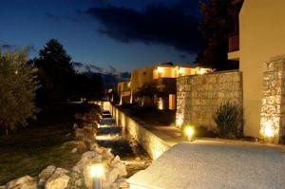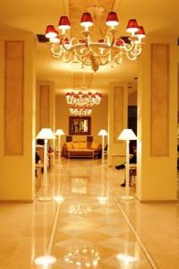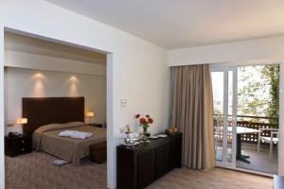

Olympian Bay Resort photos

VENUE: OLYMPIAN BAY
All the rates are in Half Board (Breakfast and one meal)

Rooms available: 200 - Suites Available on request

Prices per person H/B  Breakfast and one meal  (lunch or dinner) | OLYMPIAN BAY RESORT  VENUE  **** | Extra nights per person per day
TYPE OF ROOM | COST PER PERSON  for 10 nights | Prices for extra nights
SINGLE ROOM PACKAGE | 770 € per person | 77 € per person per day
DOUBLE ROOM PACKAGE | 520 € per person | 52 € per person per day
TRIPLE ROOM PACKAGE | 450 € per person | 45 € per person per day

The participants have the choice with 15 euros supplement per day to turn their package to All Inclusive (Second meal + unlimited drinks and coffees).

On request: Organizing Committee can provide and other hotels (3 stars) in 1.5 - 2 km distance in Bed breakfast basis. The main tournament hotel is strongly recommended to avoid any transfer.

10. PARALLEL PROGRAM

10.1. Excursions Program - The O.C. will organize excursions & mini tours in ancient and famous Greek places. Mount Olympus – Dion (ancient theatre) - Vergina (ancient tombs & Museums) - Thessaloniki city tour.

10.2. For players who wish to arrive earlier, the traditional annual “ 7th Games Festival Chess Open” will be organized from 25th April to 1st May 2011 in the same venue. The regulations will be sent to to all participants.

11. CONTACT THE ORGANIZING COMMITTEE

email: seniorschess@gmail.com

Official Site: http://gamesfestival.chessdom.com

Online Bookings - www.eventravel.net

Head of the Organizing Committee
Theodoros Tsorbatzoglou
Tel.- Fax.: +30 2310865778
teotsorb@gmail.com

Tournament Manager
Savas Mavromoustakos - Treasurer
Tel. +30 2310 419269
seniorschess@gmail.com

Chief Arbiter
Almog Burstein
almogbu@walla.com

